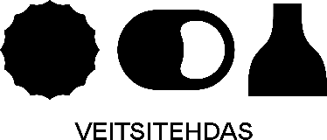

**SAFER PLACE**

**THESE ARE OUR HOUSE RULES**

We don’t accept any behavior that includes:

* Any sort of discriminiation towards someone’s ethnicity, sexual orientarion, gender expression, religion, size, socio-economic background, mental health or ability.
* Hate speech or any rude jokes that may insult people around you.
* Catcalling or other harassment of any kind
* Entering someone’s personal space – or touching them without their permission.

If you experience or see any of this kind of behavior, please come and talk with your supervisor.

**PLEASE DO NOT WORK HERE IF YOU HAVE ANY SYMPTONS OF**

* **COVID 19**
* **HOMOPHOBIA**
* **TRANSPHOBIA**
* **RACISM**
* **SEXISM**
* **ABLEISM**
* **AGEISM**

**OR ANY OTHER FORM OF HATE TOWARDS OTHER LIVING THINGS!**

**WASH YOUR HANDS - DRINK GOOD BEER!**

**BE KIND TO OTHERS.**